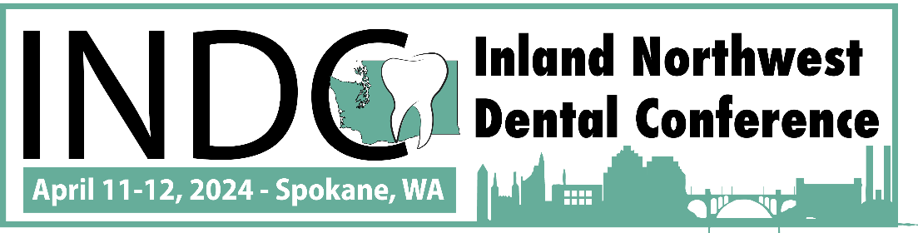

We are delighted to invite you to participate as an exhibitor at the Inland Northwest Dental Conference, scheduled to take place at the Spokane Convention Center on April 11-12, 2024. This conference promises to bring together dental professionals, industry experts, and key stakeholders, providing an excellent platform for networking, education, and showcasing your products and services to a targeted audience.
WHAT IS INDC?
The Inland Northwest Dental Conference is an annual, 2-day dental CE event held in beautiful Spokane, WA. This conference is all about professional education, development, and networking. INDC will feature valuable content from world-class industry speakers, workshops, product demonstrations, networking and more.

WHO WILL BE THERE?

The 2023 conference exceeded our expectations with over 350 attendees. For 2024, we are anticipating between 350-400 industry professionals in attendance! Dentists and their teams come from all areas of Washington as well as surrounding states to attend the conference.

WHY FACE-TO-FACE MATTERS
Even in our digitally connected world and workplaces, nothing compares to the value that face-to-face meetings, events, conferences and tradeshows provide which is why YOU should be participating in INDC! This conference will be an opportunity to connect with attendees and provide valuable in-person interactions with current and potential customers.

REGISTER ONLINE
Please CLICK HERE to view the available options and register online.
We strongly encourage your to use the online registration system for real time booth availability and online payment. There are a limited amount of exhibit spaces and sponsorship packages available and they are filled on a first-come-first-served basis. Don’t wait – book now!

WHERE TO STAY
The host hotel is the DoubleTree by Hilton Hotel, Spokane City Center which is located next to the convention center. Group rates are now live for April 10-12, 2024. To reserve your room:
Call 1-800-757-6131 for Central Reservations or 509-744-2327 and ask for the Inland NW Dental Conference Rate
or
CLICK HERE to book your discounted hotel reservation online

